Create Node-RED Service

|  |  |
| --- | --- |
| **Date** | **21-10-2022** |
| **Team ID** | **PNT2022TMID01821** |
| **Project Name** | Project - IOT Based Safety Gadget for Child safety Monitoring and  Notification |
| **Maximum Marks** | **4 Marks** |
| **Submitted By** | Sabarinathan G(7376191EC249),  Pathmaloshan C(7376191EC224),  Praneeth R(7376191EC231),  Rithik M(7376191EC246) |

Aim: To create a web application create a Node-RED service. Steps followed:

* Navigated to the App creation page

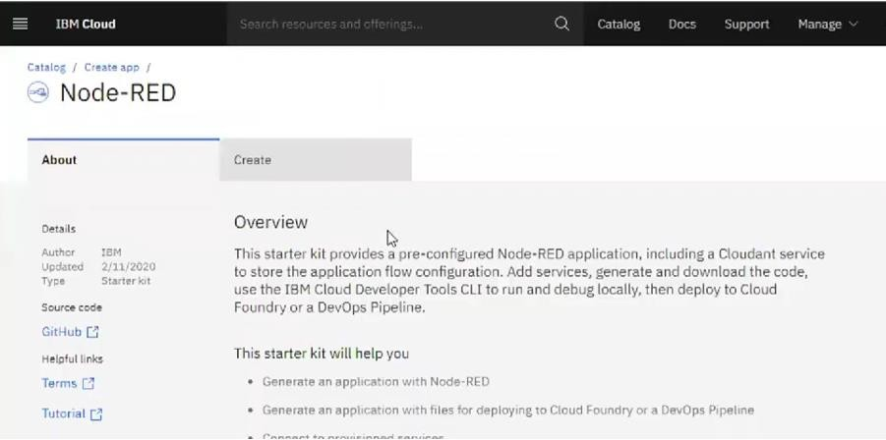

* + Entered project details and clicked on create

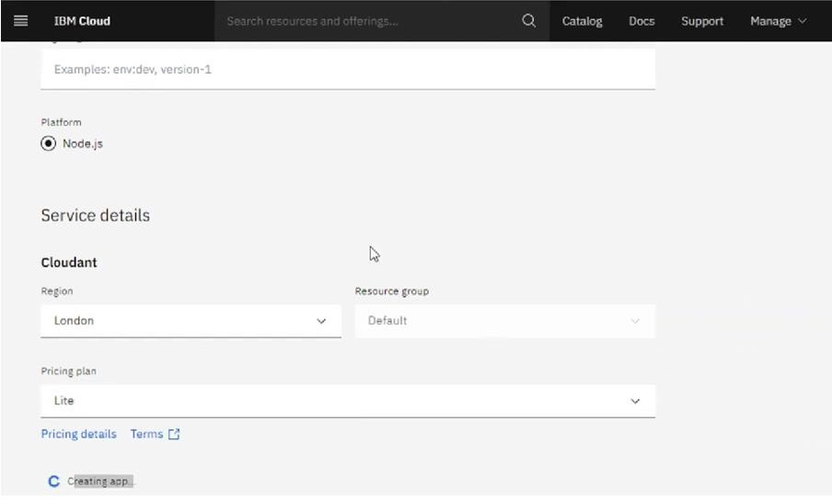

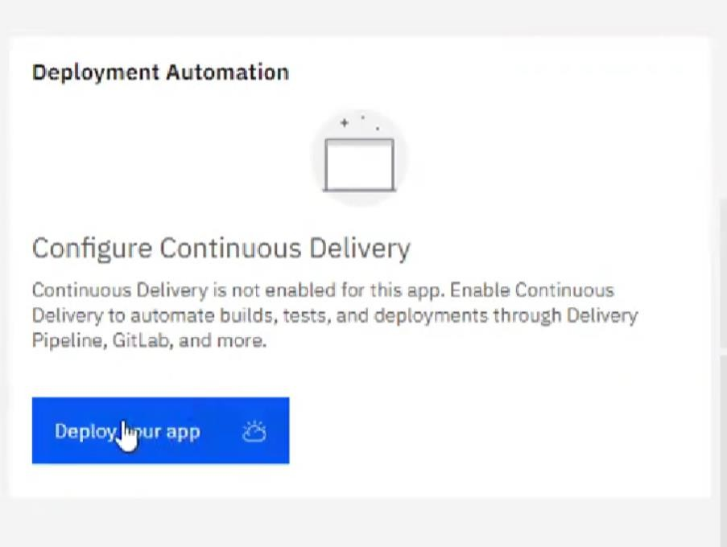

* Setting up the environment and deploying the app

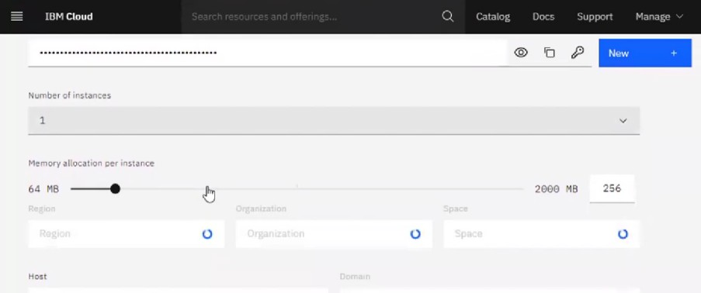

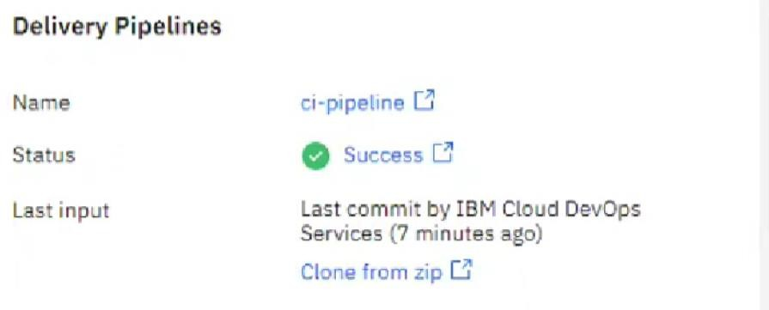

* Dragged and dropped components into the editor

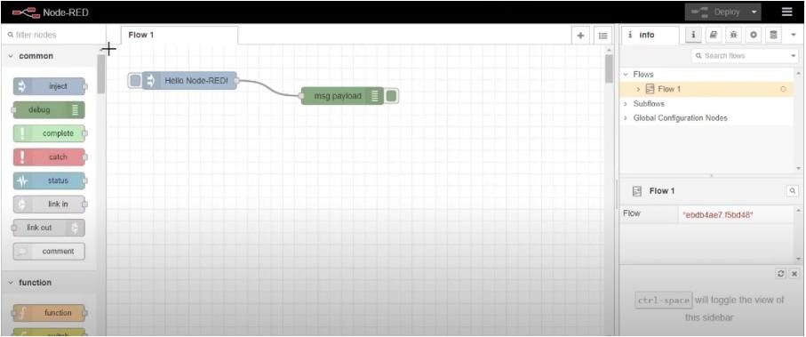

* Editing some values of the properties

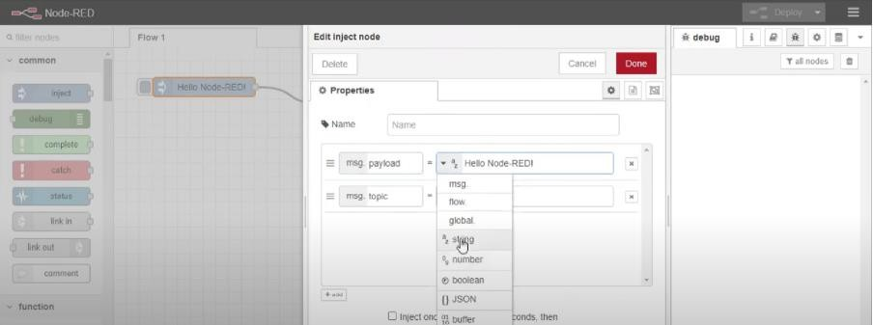

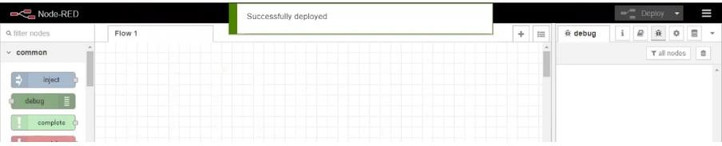

**Result: Successfully created a NodeRED service on IBM Cloud**